**Sailing Quick Reference Guide**

**Basic Sailing Terms:**

**Ease:** To let out the sails.

**Trim:** To pull the sails in

**Luffing**: The flapping of the whole sail, flogging – when sails are over eased

**Windward:** Towards the wind.

**Leeward:** Away from the wind.

**Starboard Tack:** wind is coming from the starboard (right) side of the boat

**Port Tack:** wind is coming from the port (left) side of the boat

**Basic Right of Way Rules: *Keep Clear -*** *One boat keeps clear of another if the other boat can sail her course with no need to take avoiding action and, when the boats are overlapped on the same tack, if the leeward boat could change course without immediately making contact with the windward boat.*

1. **Starboard – Port:** Port-tack boat must keep clear of starboard-tack boat

2. **Leeward – Windward:** Windward boat must keep clear of leeward boat.

3. **Clear Ahead:** Clear astern boat must keep clear of clear ahead boat

4. **Tacking:** A boat "past head to wind" (*i.e.*, "tacking") must keep clear of other boats.

5. **Sail vs. Motor:** Boat using motor power must keep clear of boat using sails

|  |  |
| --- | --- |
| **Points of Sail:** | **Sailboat Maneuvers:**  **Coming-About (Tacking):** In this maneuver, the bow of the boat goes through the wind as one changes from a close-hauled point-of-sail on one tack (direction) to a close hauled point-of-sail on the other direction. Only the jib needs to be adjusted, the working sheet of the jib is changed and the new working sheet is placed on a winch. The mainsail is left alone and will by itself often assume the correct position.  **Jibe:** In this maneuver, the stern of the boat goes through the wind as one changes from a broad reach on one tack (direction) to a broad reach in the other tack (direction). Both the jib and mainsail will need adjusting. The mainsail is first centered, the turn made and the mainsail is then let out. The jib's working sheet is changed and the new working sheet is placed on a winch.  **Head Up:** Change the boat's course toward the wind.  **Head Down:** Change the boat's course away from the wind.  **Bear Away / Fall Off:** To head away or off from the wind. |

**Sail Boat Parts Quick Reference Guide**

* **Bow**: Front of the boat.
* **Stern:** Back of the boat.
* **Starboard**: Boat's right side.
* **Port**: Boat's left side.
* **Deck:** Top of the boat which covers the hull.
* **Mast**: The main and highest spar in the center of the boat to which the jib and mainsail are attached.
* **Boom:** The horizontal spar which extends aft (backwards) from the mast to which the foot of the mainsail abuts.
* **Standing Rigging:** Supports the mast and includes the Backstay, Forestay, Shrouds.
  + - **Shrouds:** cables which give lateral stability to the mast.
    - **Spreaders:** Horizontal spars which spread the shrouds from the mast.
    - **Forestay:** A line or cable which supports the mast from the bow of the boat.
    - **Backstay:** A line or cable which supports the mast from the stern of the boat.
    - **Boom Topping Lift:** A line which extends from the boom to the mast. Supports boom when mainsail is taken down..
* **Running Rigging:** Lines which control and adjust the sails.
  + - **Halyard:** A line used to raise a sail. (Main sail halyard, jib halyard, spinnaker halyard)
    - **Sheet:** Line used to adjust a sail against the force of the wind. The mainsail has 1 sheet. The jib has a working (windward) sheet and a lazy (leeward) sheet. (Main sail sheets, jib sheets, spinnaker sheets)
    - **Boom Vang:** line which places downward tension on the boom.
    - **Outhaul:** Places backward tension on the clew of the mainsail. Flattens the lower one-third of the mainsail.
    - **Spinnaker control lines:**
* 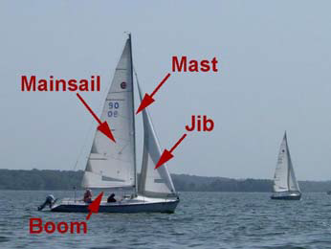**Pole Lift:** line controls height of spinnaker pole
* **Down Haul:** line keeps spinnaker pole from being pulled up by spinnaker sail
* **Spinnaker Guy:** the spinnaker sheet on the pole or windward side of the boat
* **Twing:** line used to pull the spinnaker guy down closer to the hull.
  + - **Winch:** A device used to tighten a line.
    - **Cleat:** A metal or plastic device used to secure a line. There are many types of cleats.
    - **Block:** A device used to change a line's direction.
* 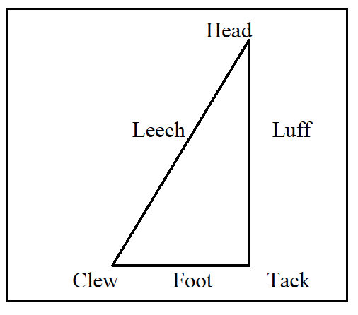**Sails:**

|  |
| --- |
| * **Mainsail:** The sail aft of the mast which is attached to the mast and the boom. * **Headsail/Jib:** The sail between the forestay and the mast. Also called the headsail. There are several sizes of Jibs. * **Genoa Jib** ( #1) overlaps the mainsail and is used to provide maximum power in light winds. * **Working Jib** ( #3) smaller jib which fills the space between the mast and forestay. Used in stronger winds. * **Spinnaker:** A large balloon sail attached to the mast at the front of the boat. Used when sailing downwind. |